Available Online at www.ijcsmc.com

International Journal of Computer Science and Mobile Computing

A Monthly Journal of Computer Science and Information Technology

ISSN 2320–088X
IJCSMC, Vol. 2, Issue. 1, January 2013, pg.22 – 27
REVIEW ARTICLE
Medical Image Segmentation: A Review
Prof. Dinesh D. Patil¹, Ms. Sonal G. Deore²
1
S.S.G.B.C.O.E.T. Bhusawal, Dept. Of Computer Engg, Jalgaon, Maharashtra, India dineshonly@gmail.com
2
S.S.G.B.C.O.E.T. Bhusawal, Dept. Of Computer Engg, Jalgaon, Maharashtra, India sonal_vaghode26@rediffmail.com

Abstract— Image segmentation is the most critical functions in image analysis and processing. Fundamentally segmentation results affect all the subsequent processes of image analysis such as object representation and description, feature measurement, and even the following higher level tasks such as object classification. Hence, image segmentation is the most essential and crucial process for facilitating the delineation, characterization, and visualization of regions of interest in any medical image. Manual segmentation of medical image by the radiologist is not only a tedious and time consuming process, but also not very accurate especially with the increasing medical imaging modalities and unmanageable quantity of medical images that need to be examined. It becomes therefore necessary to review current methodologies of image segmentation using automated algorithms that are accurate and require as little user interaction as possible especially for medical images. In the segmentation process, the anatomical structure or the region of interest needs to be delineated and extracted out so that it can be viewed individually. In this paper we project the important place of segmentation of images in extracting information for decision making.

Indexed Terms: - Medical image segmentation, image analysis

I. INTRODUCTION
Medical images play vital role in assisting health care providers to access patients for diagnosis and treatment. Studying medical images depends mainly on the visual interpretation of the radiologists. However, this consumes time and usually subjective, depending on the experience of the radiologist. Consequently the use of computer-aided systems becomes very necessary to overcome these limitations. Artificial Intelligence methods such as digital image processing when combined with others like machine learning, fuzzy logic and pattern recognition are so valuable in Image techniques can be grouped under a general framework; Image Engineering (IE). This is comprised of three layers: image processing (lower layer), image analysis (middle layer), and image understanding (high layer), as shown in Fig 1. Image segmentation is shown to be the first step and also one of the most critical tasks of image analysis. Its objective is that of extracting information (represented by data) from an image via image segmentation, object representation, and feature measurement, as shown in Fig 1. Result of segmentation; obviously have considerable influence over the accuracy of feature measurement [2]. The computerization of medical image segmentation plays an important role in medical imaging applications. It has found wide application in different areas such as diagnosis, localization of pathology, study of anatomical structure, treatment planning, and computer-integrated surgery. However, the variability and the complexity of the anatomical structures in the human body have resulted in medical image segmentation remaining a hard problem [3].
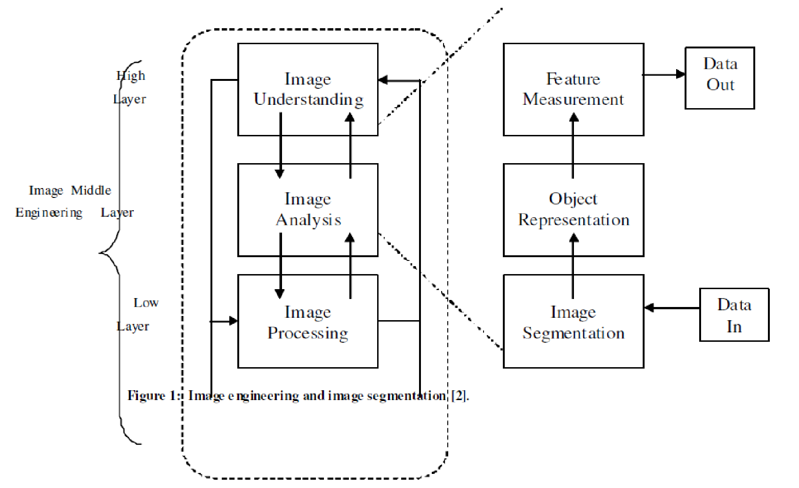
Figure 1: Image engineering and image segmentation [2].

Based on different technologies, image segmentation approaches are currently divided into following categories, based on two properties of image.
- Detecting Discontinuities
It means to partition an image based on abrupt changes in intensity [1], this includes image segmentation algorithms like edge detection.
- Detecting Similarities
It means to partition an image into regions that are similar according to a set of predefined criterion [1]; this includes image segmentation algorithms like Thresholding, region growing, region splitting and merging. Thresholding is a very common approach used for Region based segmentation where an image represented as groups of pixels with values greater or equal to the threshold and values less to threshold value.

Clustering is also an approach for region segmentation where an image is partitioned into the sets or clusters of pixels having similarity in feature space. Region growing is another approach of region segmentation algorithms where assigned the adjacent pixels or regions to the same segment. There are three types of images as gray scale, hyper spectral and medical images.

II. SEGMENTATION BASED ON EDGE DETECTION

This method attempts to resolve image segmentation by detecting the edges or pixels between different regions that have rapid transition in intensity are extracted [1, 5] and linked to form closed object boundaries. The result is a binary image [2]. Based on theory there are two main edge based segmentation methods- gray histogram and gradient based method [4].
Edge detection is a well-developed field on its own within image processing. Region boundaries and edges are closely related, since there is often a sharp adjustment in intensity at the region boundaries. Edge detection techniques have therefore been used as the base of another segmentation technique. The edges identified by edge detection are often disconnected. To segment an object from an image however, one needs closed region boundaries. The desired edges are the boundaries between such objects.
Segmentation methods can also be applied to edges obtained from edge detectors. Lindeberg and Li ^{[8]} developed an integrated method that segments edges into straight and curved edge segments for partsbased object recognition, based on a minimum description length (MDL) criterion that was optimized by a splitand-merge-like method with candidate breakpoints obtained from complementary junction cues to obtain more likely points at which to consider partitions into different segments.

III. THRESHOLDING METHOD
Thresholding algorithms can be selected manually according to a priori knowledge or automatically by image information. These algorithms further divided to edge-based, region-based and hybrid. Edge-based algorithms are related with the edge information. The Structures of an object can be depicted by edge points. Common edge detection algorithms such as canny edge detector and Laplacian edge detector can be classified to this type of regions. These algorithms are used to find the edge pixels while eliminating the noise influence.
For example, canny edge detector used the threshold of gradient magnitude to find the potential edge pixels and suppressed them through the procedures of the non-maximal suppression and hysterics Thresholding. As the operations used in these algorithms are based on pixels, the detected edges are consisted of discrete pixels and hence may be incomplete or discontinuous. Hence, it must be apply the post processing like morphological operation to connect the breaks or eliminate the holes. This method has the ability that can be used to segment 3D image with good accuracy, but the disadvantage of this method is the difficulty to process the images of textured blob objects.
Image segmentation by Thresholding is a simple but powerful approach for segmenting images having light objects on dark background [1]. Thresholding technique is based on image space regions i.e. on characteristics of image [4]. Thresholding operation convert a multilevel image into a binary image i.e., it choose a proper threshold T, to divide image pixels into several regions and separate objects from background. Any pixel (x, y) is considered as a part of object if its intensity is greater than or equal to threshold value i.e., f(x, y) ≥T, else pixel belong to background [3, 11]. As per the selection of Thresholding value, two types of Thresholding methods are in existence [12], global and local Thresholding. When T is constant, the approach is called global Thresholding otherwise it is called local Thresholding. Global Thresholding methods can fail when the background illumination is uneven. In local Thresholding, multiple thresholds are used to compensate for uneven illumination [8]. Threshold selection is typically done interactively however; it is possible to derive automatic threshold selection algorithms.
Limitation of Thresholding method is that, only two classes are generated, and it cannot be applied to multichannel images. In addition, Thresholding does not take into account the spatial characteristics of an image due to this it is sensitive to noise [4], as both of these artifacts corrupt the histogram of the image, making separation more difficult.

IV. REGION BASED SEGMENTATION METHODS
Compared to edge detection method, segmentation algorithms based on region are relatively simple and more immune to noise [4, 6]. Edge based methods partition an image based on rapid changes in intensity near edges whereas region based methods, partition an image into regions that are similar according to a set of predefined criteria [10, 1]. Segmentation algorithms based on region mainly include following methods:
1. Region Growing
Region growing is a procedure [2-3] that group’s pixels in whole image into sub regions or larger regions based on predefined criterion [13]. Region growing can be processed in four steps:- (i) Select a group of seed pixels in original image [7].
- Select a set of similarity criterion such as grey level intensity or color and set up a stopping rule.
- Grow regions by appending to each seed those neighboring pixels that have predefined properties similar to seed pixels.
- Stop region growing when no more pixels met the criterion for inclusion in that region (i.e. Size, likeness between a candidate pixel & pixel grown so far, shape of the region being grown)
2. Region Splitting and Merging
Rather than choosing seed points, user can divide an image into a set of arbitrary unconnected regions and then merge the regions [2, 4] in an attempt to satisfy the conditions of reasonable image segmentation. Region splitting and merging is usually implemented with theory based on quad tree data.
Let R represent the entire image region and select a predicate Q
- We start with entire image if Q(R) = FALSE [1], we divide the image into quadrants, if Q is false for any quadrant that is, if Q (Ri) = FALSE, We subdivide the quadrants into sub quadrants and so on till no further splitting is possible.
- If only splitting is used, the final partition may contain adjacent regions with identical properties. This drawback can be remedied by allowing merging as well as splitting i.e. merge any adjacent regions Rj & Rk for which ,Q(Rj U Rk) = TRUE (iii) Stop when no further merging is possible.

V. SEGMENTATION BASED ON CLUSTERING
Clustering is an unsupervised learning task, where one needs to identify a finite set of categories known as clusters to classify pixels [17]. Clustering use no training stages rather train themselves using available data. Clustering is mainly used when classes are known in advance. A similarity criteria is defined between pixels [2], and then similar pixels are grouped together to form clusters. The grouping of pixels into clusters is based on the principle of maximizing the intra class similarity and maximizing the inter class similarity. The quality of a clustering result depends on both the similarity measure used by the method and its implementation. Clustering algorithms are classified as hard clustering, k- means clustering, fuzzy clustering, etc.

VI. HYBRID IMAGE SEGMENTATION USING WATERSHED AND FAST REGION MERGING
There is a general segmentation problem as how to segment an image into homogeneous segments such that after combining two neighbours it gives a heterogeneous segment. There are many techniques for an error-free image partitions as histogram-based represents the simple probability distribution function of intensity values of any image. Edge based technique used to detect using differential filter in order of image gradient or Laplacian and then grouped them into contours represents the surface. In the region-based segmentation technique segment the image into a set of homogeneous regions then merged them according to certain decision rules [7]. In the Markov random field based segmentation technique the true image is realized by a Markov or Gibbs random field with a distribution function. Hybrid segmentation techniques are combined such as edge based and region based techniques. In this image is firstly partitioned into regions and then merged them using split and merge technique and after that detected the contours using edge-based technique
TABLE 1 COMPARISON OF IMAGE SEGMENTATION TECHNIQUES

Segmentation |  | Method description | Advantages |  | Disadvantages
technique
Thresholding method |  | Requires that the histogram of an image has a number of peaks, each corresponds to a region | It does not need prior information of the image.  For a wide class of images satisfying the requirement, this method works very well with low computation  complexity |  | (1) Does not work well for an image without any obvious peaks or with broad and flat valleys
 |  |  |  |  | (2) Does not consider the spatial details, so cannot guarantee that the segmented regions are contiguous
Clustering Approach |  | Assumes that each region in the image forms a separate cluster in the feature space. Can be generally broken into two steps: (1) categorize the points in the feature space into clusters; (2) map the clusters back to the spatial domain to form separate regions | Straightforward for classification and easy for implementation |  | (1) How to determine the number of clusters (known as  cluster validity)
 |  |  |  |  | (2) Features are often image dependent and how to select features so as to obtain satisfactory segmentation results remains unclear
 |  |  |  |  | (3) Does not utilize spatial information
Region-based approaches |  | Group pixels into homogeneous regions. Including region growing, region splitting, region merging or their combination | Work best when the region homogeneity criterion is easy to define. They are also more noise immune than edge  detection approach |  | - Are by nature sequential and quite expensive both in  computational time and memory  - Region growing has inherent dependence on the selection of seed region and the order in which pixels and regions are examined
Segmentation |  | Method description | Advantages | Disadvantages
technique
 |  |  |  | (3) The resulting segments by region splitting appear too square due to the splitting scheme
Edge approaches | detection | Based on the detection of discontinuity, normally tries to locate points with more or less abrupt changes in gray level. Usually classified into two categories:  sequential and parallel | Edge detecting technique is the way in which human perceives objects and works well for images having good contrast between regions | (1) Does not work well with images in which the edges are ill-defined or there are too many edges
 |  |  |  | (2) It is not a trivial job to produce a closed curve or boundary
 |  |  |  | (3) Less immune to noise than other techniques, e.g., Thresholding and clustering

VII. CONCLUSION
In this study, the overview of various segmentation methodologies applied for digital image processing is explained briefly. The study also reviews the research on various research methodologies applied for image segmentation and various research issues in this field of study. This study aims to provide a simple guide to the researcher for those carried out their research study in the image segmentation.
Image segmentation has a promising future as the universal segmentation algorithm and has become the focus of contemporary research. In spite of several decades of research up to now to the knowledge of authors, there is no universally accepted method for image segmentation, as the result of image segmentation is affected by lots of factors, such as: homogeneity of images, spatial characteristics of the image continuity, texture, image content. Thus there is no single method which can be considered good for neither all type of images nor all methods equally good for a particular type of image. Due to all above factors, image segmentation remains a challenging problem in image processing and computer vision and is still a pending problem in the world.

REFERENCES
- Rastgarpour M., and Shanbehzadeh J., Application of AI Techniques in Medical Image Segmentation and Novel Categorization of Available Methods and Tools, Proceedings of the International MultiConference of Engineers and Computer Scientists 2011 Vol I, IMECS 2011, March 16-18, 2011, Hong Kong.
- Zhang, Y. J, An Overview of Image and Video Segmentation in the last 40 years, Proceedings of the 6th International Symposium on Signal Processing and Its Applications, pp. 144-151, 2001.
- Wahba Marian, An Automated Modified Region Growing Technique for Prostate Segmentation in TransRectal Ultrasound Images, Master’s Thesis, Department of Electrical and Computer Engineering, University of Waterloo, Waterloo, Ontario, Canada, 2008.
- W. X. Kang, Q. Q. Yang, R. R. Liang,“The Comparative Research on Image Segmentation Algorithms”, IEEE Conference on ETCS, pp. 703-707, 2009.
- N. R. Pal, S. K. Pal,“A Review on Image Segmentation Techniques”, Pattern Recognition, Vol. 26, No. 9, pp. 1277- 1294, 1993.
- H. Zhang, J. E. Fritts, S. A. Goldman,“Image Segmentation Evaluation: A Survey of unsupervised methods”, computer vision and image understanding, pp. 260-280, 2008.
- K. K. Singh, A. Singh,“A Study of Image Segmentation Algorithms for Different Types of Images”, International Journal of Computer Science Issues, Vol. 7, Issue 5, 2010.
- T. Lindeberg and M.-X. Li "Segmentation and classification of edges using minimum description length approximation and complementary junction cues", Computer Vision and Image Understanding, vol. 67, no. 1, pp. 88--98, 1997.
- P. Karch, I. Zolotova,“An Experimental Comparison of Modern Methods of Segmentation”, IEEE 8th International Symposium on SAMI, pp. 247-252, 2010.
- H. G. Kaganami, Z. Beij,“Region Based Detection versus Edge Detection”, IEEE Transactions on Intelligent information hiding and multimedia signal processing, pp. 1217-1221, 2009.
- L.Aurdal,“Image Segmentation beyond thresholding”, Norsk Regnescentral, 2006.
- Y. Zhang, H. Qu, Y. Wang,“Adaptive Image Segmentation Based on Fast Thresholding and Image Merging”, Artificial reality and Telexistence-Workshops, pp. 308-311, 1994.
- Y. Chang, X. Li,“Adaptive Image Region Growing”, IEEE Trans. On Image Processing, Vol. 3, No. 6, 1994.
- T. Gevers, V. K. Kajcovski,“Image Segmentation by direct region subdivision”, Proceedings of the 12th IAPR International Conference on Pattern Recognition, Vol. 1.
- X. Jiang, R. Zhang, S. Nie,“Image Segmentation Based on PDEs Model: a Survey”, IEEE conference, pp. 1-4, 2009.
- C. Zhu, J. Ni, Y. Li, G. Gu,“General Tendencies in Segmentation of Medical Ultrasound Images”, International Conference on ICICSE, pp. 113-117, 2009.
- V. K. Dehariya, S. K. Shrivastava, R. C. Jain,“Clustering of Image Data Set Using K-Means and Fuzzy KMeans Algorithms”, International conference on CICN, pp. 386- 391, 2010.
- F .Z. Kettaf, D. BI, J. P.,“A Comparison Study of Image Segmentation by Clustering Technique”, Proceedings of ICSP, pp. 1280-1282, 1996.
- S. Naz, H. Majeed, H. Irshad,“Image Segmentation using Fuzzy Clustering: A Survey”, International Conference on ICET, pp.181-186, 2010.
- S.Tatiraju, A. Mehta,“Image Segmentation using k-means clustering, EM and Normalized Cuts”, Department of EECS, pp. 1-7.
- B. C. Wei, R. Mandava,“Multi–objective Nature-inspired Clustering Techniques for Image Segmentation”, IEEE Conference on CIS, pp.150-155, 2010.
- B. C. Wei, R. Mandava,“Multiobjective optimization Approaches in Image Segmentation- the Direction and Challenges”, ICSRS Publication, 2010.
- P.Lukac, R. Hudec, M. Benco, P. Kamencay, Z. Dubcova, M. Zachariasova,“Simple Comparison of Image Segmentation Algorithms Based on Evaluation Criterion”, IEEE Conference on Radioelektronika, pp. 1-4, 2011.

